Alumni Meet Day Report

Program Driven by | L.B.H.S.S.Trust’s Institute of Computer Application and Alumni Association
Type of Activity | Celebration Activity
Activity Name | Alumni Meet 2026
Program Theme | -------
Mode of Conduct | Offline
Time | 9.00am to 2pm
Date | 07-02-2026
Number of student Participants | 38
Number of Faculty Participants | 9
Expenditure Amount ,If any | 23,500 Rs. approximately
Objective | - To call pass out students and held official meeting with college faculties  - To seek help from Alumnus for college growth/Placement
Benefit in-terms of learning/skill/  knowledge e obtained | • The alumni meet provided networking opportunities by connecting students with former students working in various fields.  • It offered career guidance and mentorship, where alumni shared their experiences and career journeys.  • The meet inspired and motivated students by showcasing the achievements of successful alumni.  • Alumni shared knowledge about current industry trends, skills, and opportunities, which benefited students and faculties.  • The event enhanced the reputation of the institution by highlighting the success of its alumni.  • It supported placements and internships, as alumni guided students and offered referrals and opportunities.  • The meet strengthened relationships among alumni and rebuilt their emotional connection with the institution.  • Alumni contributed to institutional development through suggestions, resources, and support.  • Students gained confidence and improved their communication skills by interacting with alumni.  • The event helped in building a strong and active alumni network for future collaboration.
Poster sample& Collage Photo | 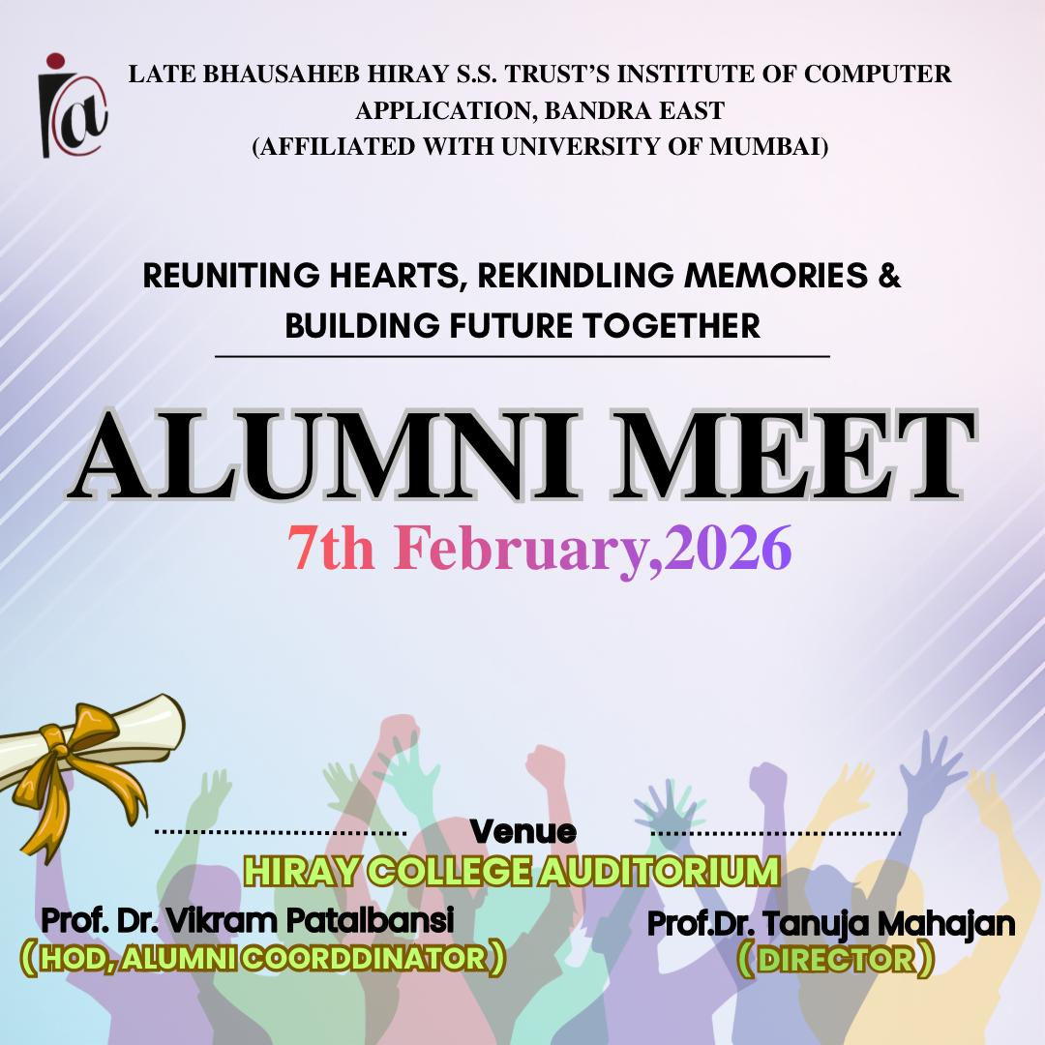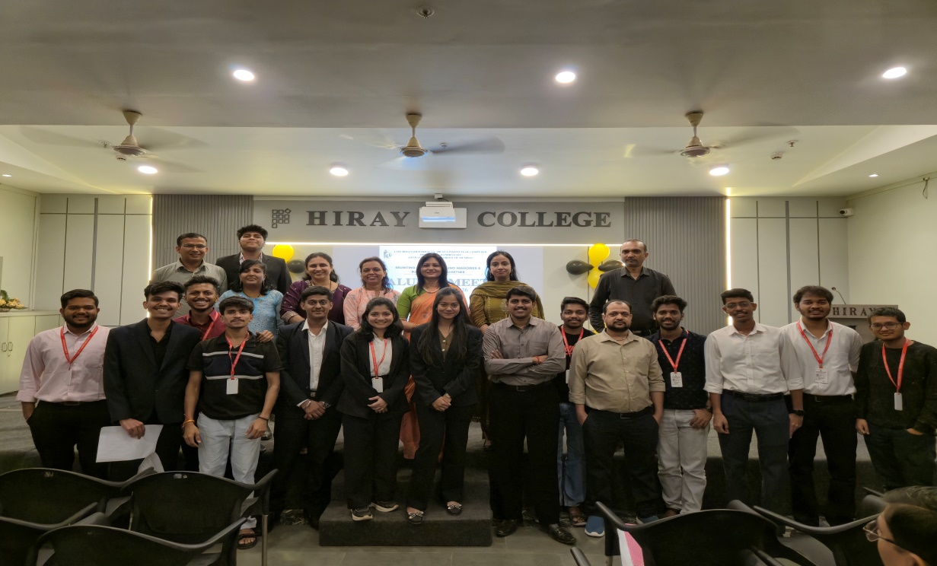  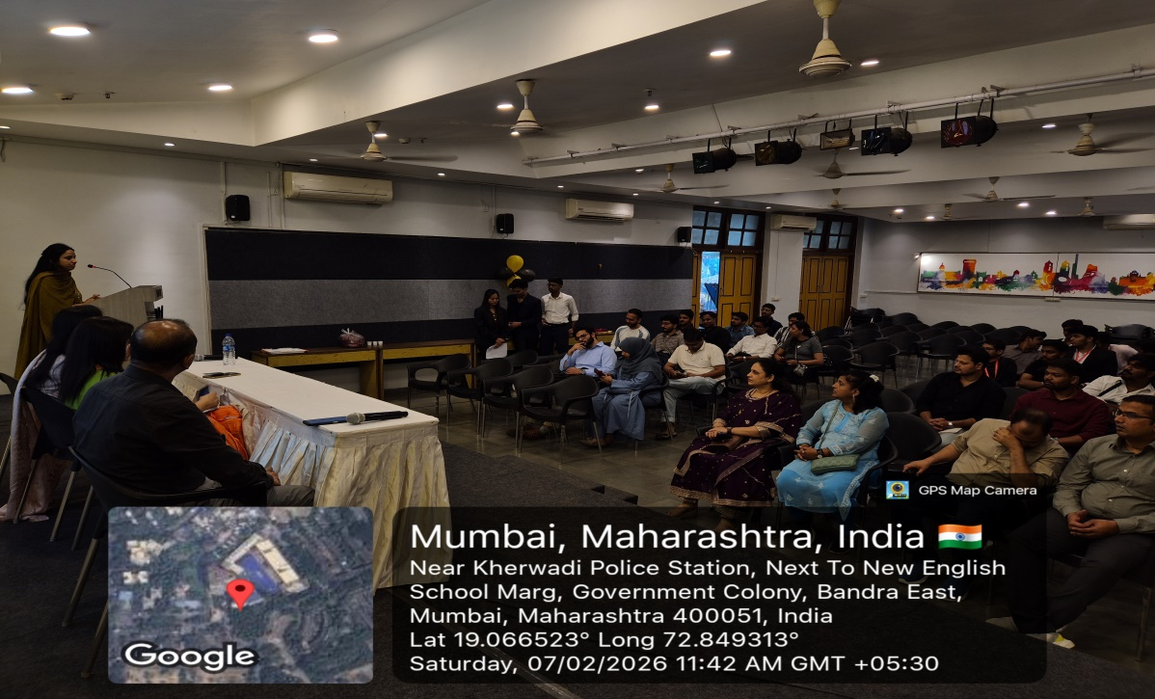  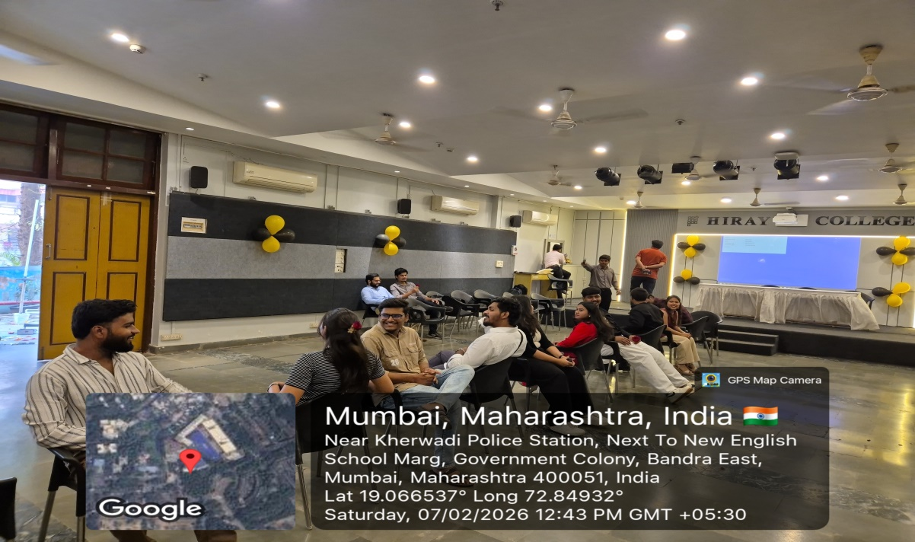  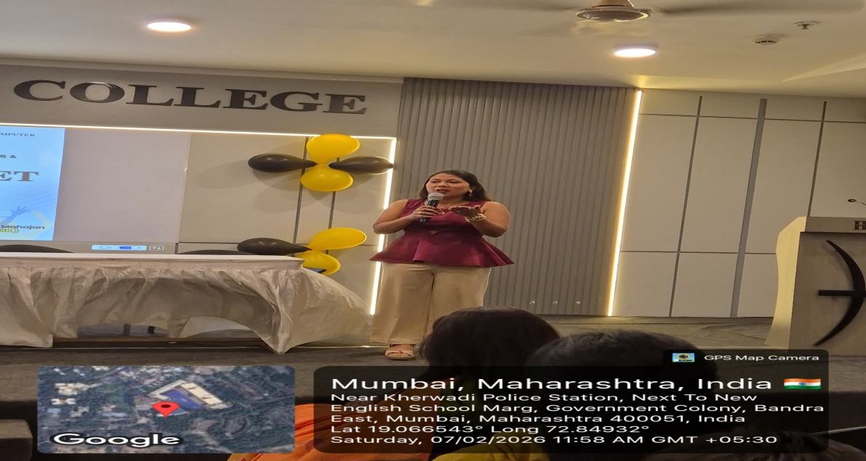  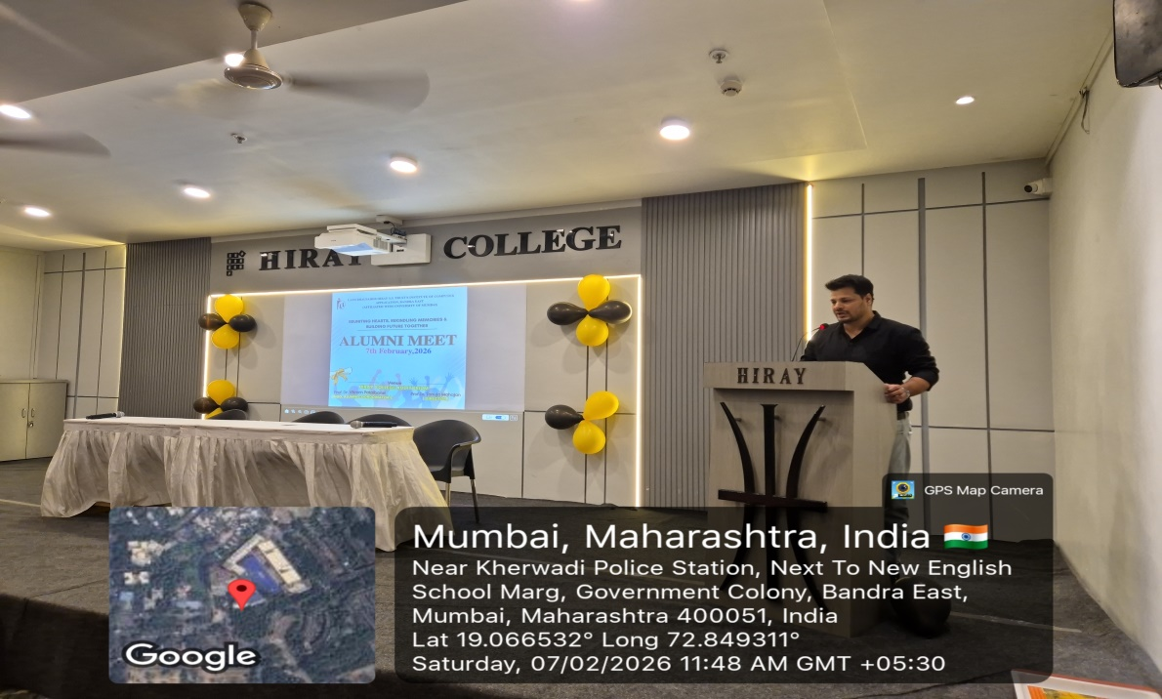
Feedback sample | Attached
Registration/ Attendance | Attached

Alumni Meet Coordinator Director

