Alumni Meet Day Report

Program Driven by | L.B.H.S.S.Trust’s Institute of Computer Application and Alumni Association
Type of Activity | Celebration Activity
Activity Name | Alumni Meet 2025
Program Theme | -------
Mode of Conduct | Offline
Time | 4:00 pm to 8:00 pm
Date | 09-02-2025
Number of student Participants | 38
Number of Faculty Participants | 8
Expenditure Amount ,If any | 12,000 Rs. approximately
Objective | - To call pass out students and held official meeting with college faculties  - To seek help from Alumnus for college growth
Benefit in-terms of learning/skill/  knowledge e obtained | Near about 38 pass out Alumni joined this program and shared their experience regarding their college life and professional growth.
Poster sample& Collage Photo | 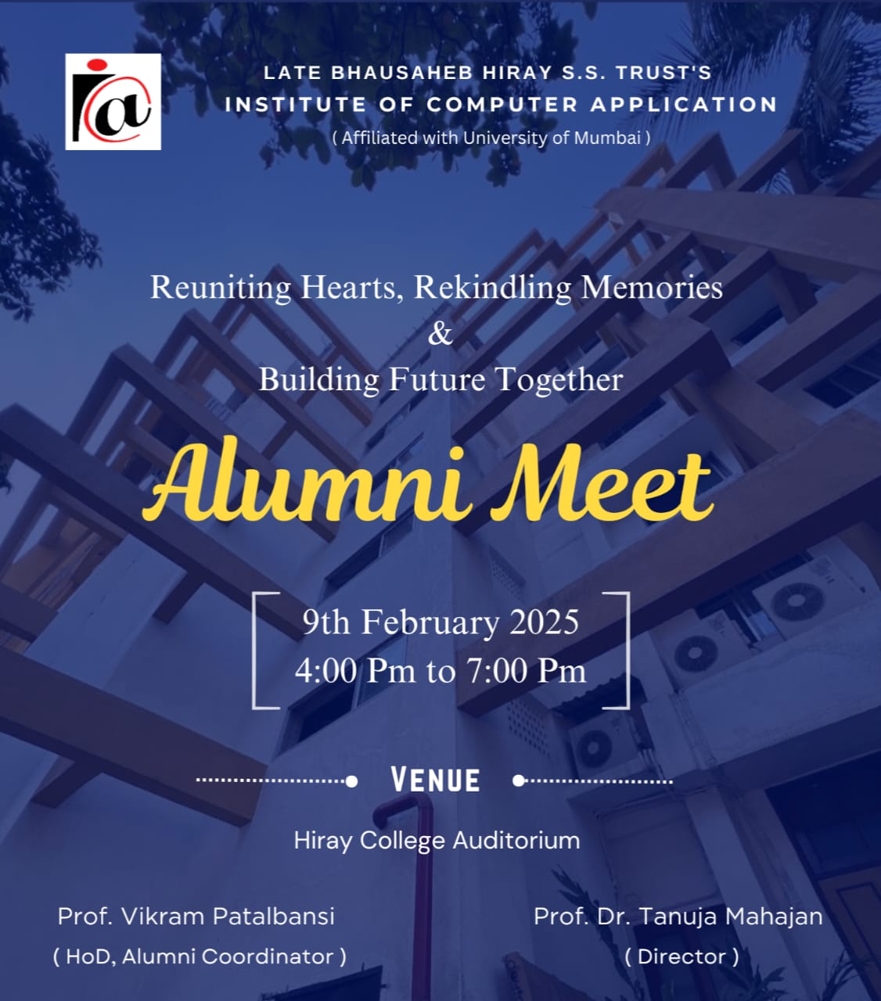  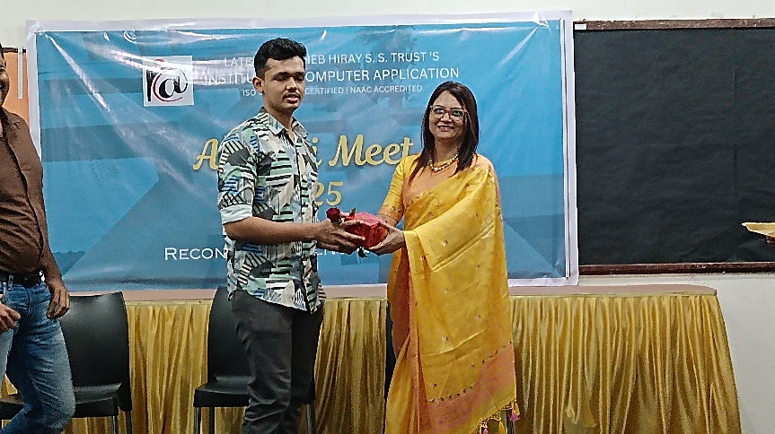  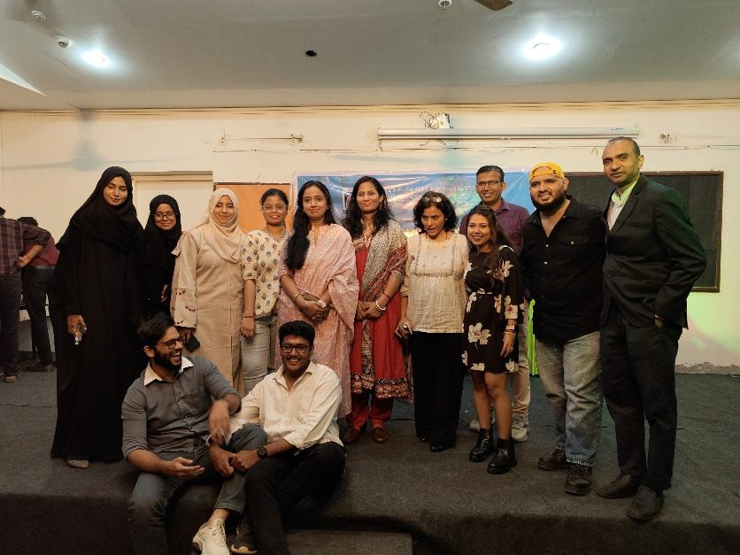
Feedback sample | Attached
Registration/ Attendance | Attached
Resource person profile information | -------------

Alumni Meet Coordinator Director

