React.js workshop 2025 Report

Program Driven by | L.B.H.S.S.Trust’s Institute of Computer Application
Type of Activity | Seminar
Activity Name | Workshop on React.Js
Program Theme | Workshop
Mode of Conduct | Online
Time | 9:00 am to 2:00 pm
Date | 20-11-2025
Number of student Participants | 87
Number of Faculty Participants | 8
Expenditure Amount ,If any | 5000
Objective | - Provide hands-on training on React.Js  - To make students placement ready in this technology.
Benefit in-terms of learning/skill/  knowledge e obtained | • Gained a clear understanding of React.js fundamentals, including components, JSX, props and state.  • Developed hands-on skills in building interactive and reusable UI components.  • Learned to manage application state efficiently using Hooks such as useState and useEffect.  • Understood the concept of Virtual DOM and how React improves UI performance.  • Improved ability to create Single Page Applications (SPAs) with smooth navigation and routing.  • Enhanced knowledge of modern JavaScript (ES6+) features commonly used in React development.  • Became familiar with development tools like Node.js, npm, React Developer Tools and VS Code.  • Strengthened problem-solving, debugging and front-end architecture skills.  • Gained exposure to industry-relevant workflows such as component modularity, code reusability and version control.  • Built confidence to work on real-world web development projects and continue learning advanced React concepts.
Poster sample& Collage Photo | 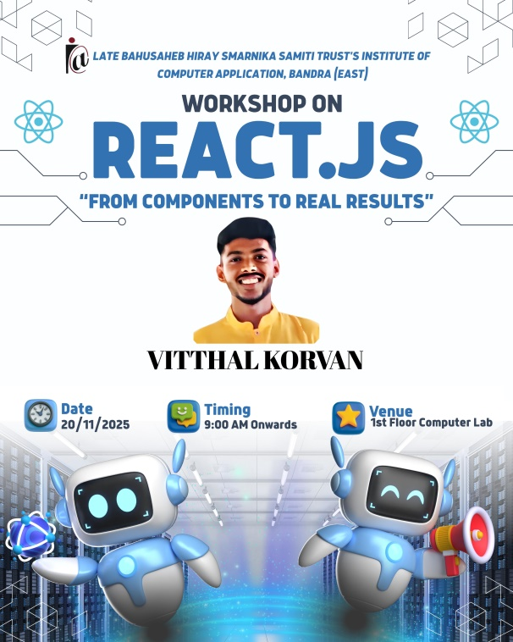  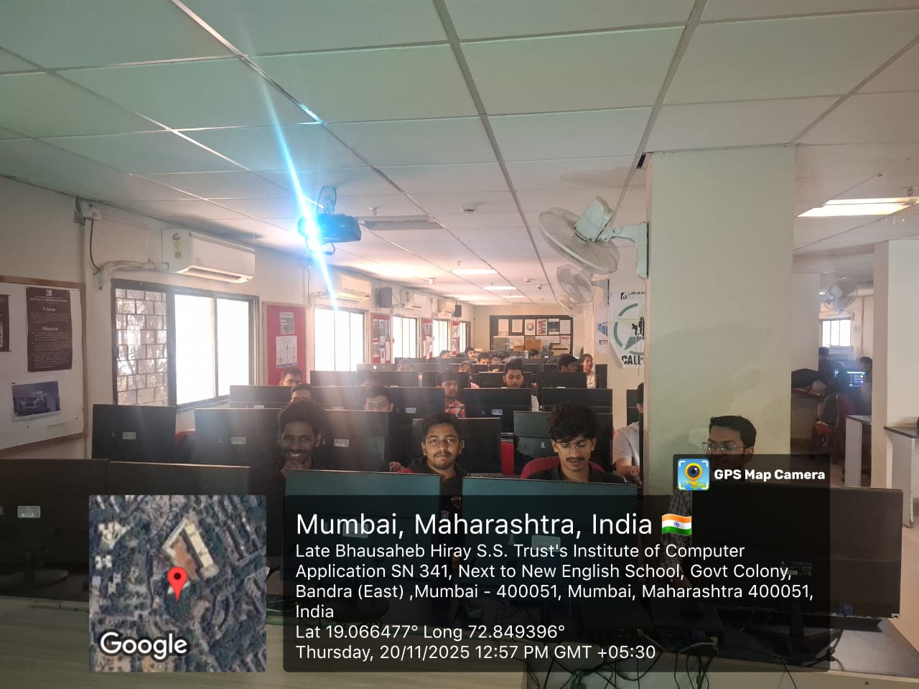  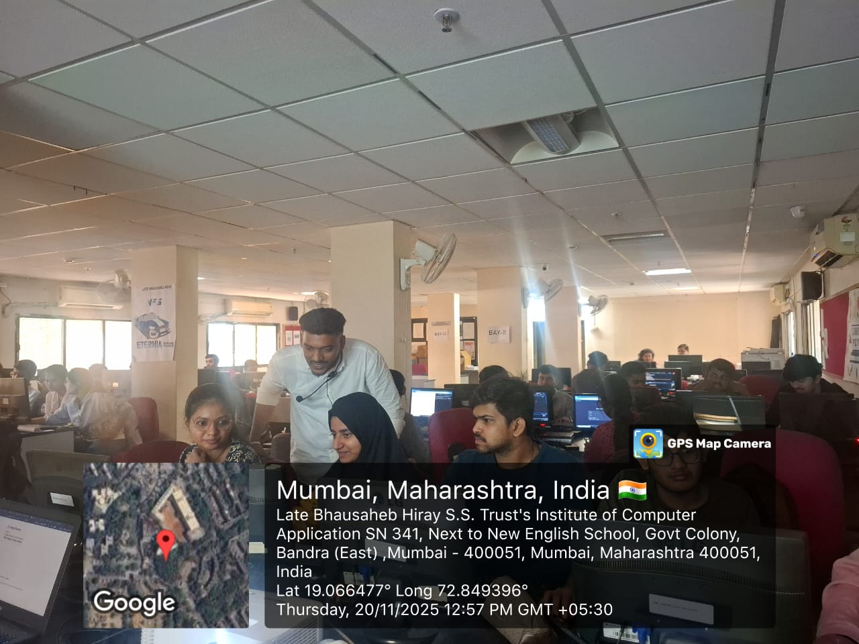  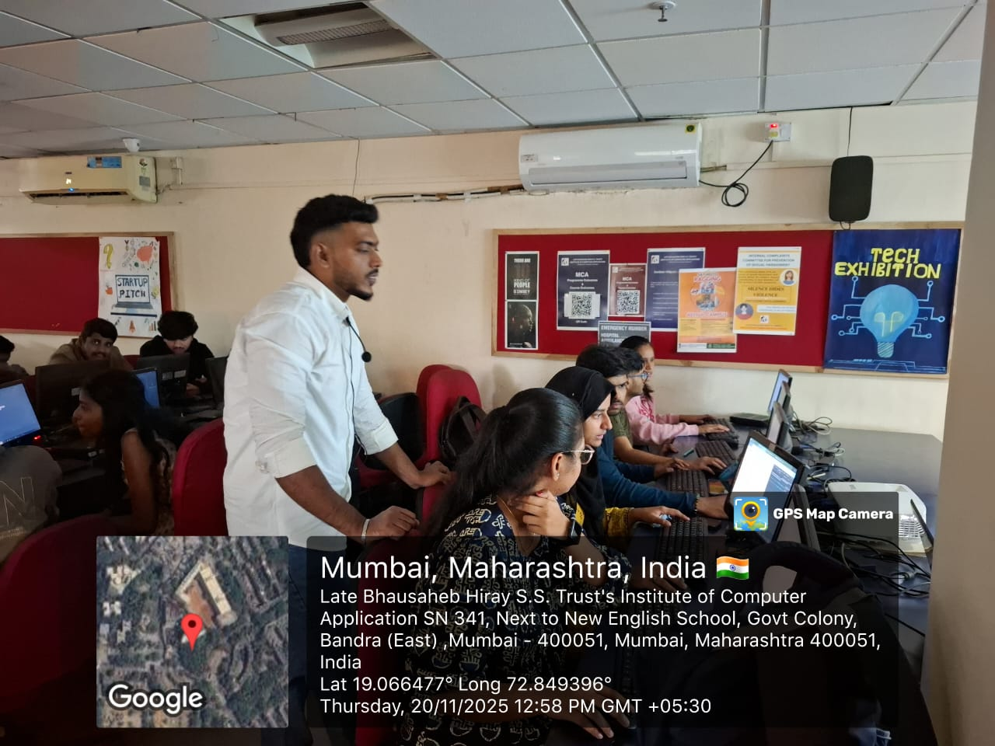
Feedback sample | Attached
Registration/ Attendance | Attached
Resource person profile information | Mr. Vitthal Korvan  Company Name: Code Subtle  Phone Number: 8104328412

Event Coordinator Director

