Awareness on Rights,Responsibilities and Entitlements regarding Sexual Harassment 2025 Report

Program Driven by | L.B.H.S.S.Trust’s Institute of Computer Application
Type of Activity | Seminar
Activity Name | Awareness on Rights, Responsibilities and Entitlements regarding Sexual Harassment
Program Theme
Mode of Conduct | Offline
Time | 1:30 pm to 2:30 pm
Date | 08-12-2025
Number of student Participants | 20
Number of Faculty Participants | 8
Expenditure Amount ,If any
Objective | Create awareness about rights and responsibilities for sexual harassment.
Benefit in-terms of learning/skill/  knowledge e obtained | 1. Enhanced Understanding of Legal Rights  - Participants gain clear knowledge of laws related to sexual harassment (e.g., POSH Act, 2013).  - Understand what legally constitutes sexual harassment and what protections are available.  - Learn about workplace and institutional mechanisms such as the Internal Complaints Committee (ICC).  2. Improved Awareness of Responsibilities  - Learn individual responsibilities in maintaining a safe, respectful environment.  - Understand the ethical and behavioural expectations placed on employees/students.  - Gain clarity on the duty to report incidents and support affected individuals.  3. Knowledge of Complaint Procedures  - Learn step-by-step procedures for reporting harassment.  - Understand timelines, documentation needed, confidentiality norms, and follow-up processes.  - Become familiar with institutional support systems and grievance redressal mechanisms.  4. Development of Communication and Assertion Skills  - Improve confidence to speak up against inappropriate behaviour.  - Learn assertive communication techniques to set boundaries.  - Gain skills in expressing concerns respectfully but firmly.  5. Improved Ability to Identify and Prevent Harassment  - Learn to recognize subtle and overt forms of harassment.  - Understand preventive strategies and proactive interventions.  - Gain skills to intervene safely as a bystander.  6. Empowerment and Confidence Building  - Participants feel empowered to protect their own rights.  - Increased confidence to challenge discrimination or misconduct.  - Develop self-advocacy skills to stand up for oneself and others.  7. Strengthened Ethical and Professional Conduct  - Encourages respectful interactions and zero-tolerance attitudes.  - Builds a culture of dignity, equality, and gender sensitivity.  - Enhances professionalism in the workplace/institution.  8. Enhanced Sensitivity and Empathy  - Improve understanding of the psychological impact of harassment on victims.  - Become more empathetic, supportive, and sensitive in responding to cases.  - Learn appropriate ways to help a person who experiences harassment.  9. Better Decision-Making and Critical Thinking  - Learn to evaluate situations ethically.  - Gain clarity on what constitutes acceptable and unacceptable behaviour.  - Develop the ability to make informed decisions regarding reporting and intervention.  10. Awareness of Entitlements and Support Systems  - Gain information about available counselling, legal assistance, and support services.  - Understand the rights to a safe environment free from harassment.  - Learn about compensation, protection, and victim-support entitlements.
Poster sample& Collage Photo | 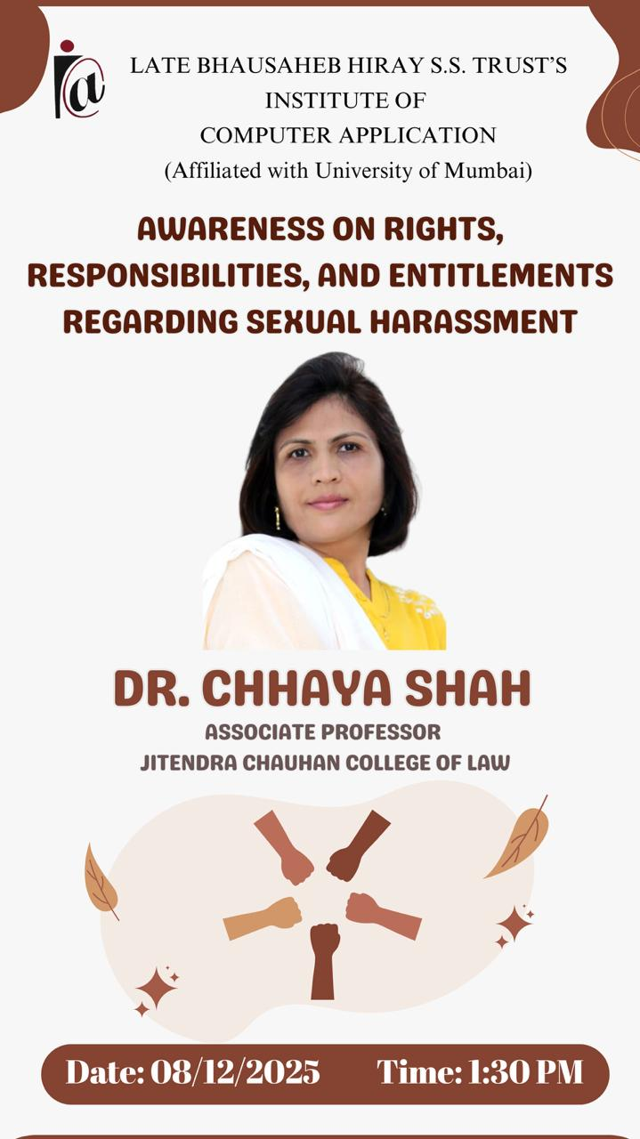  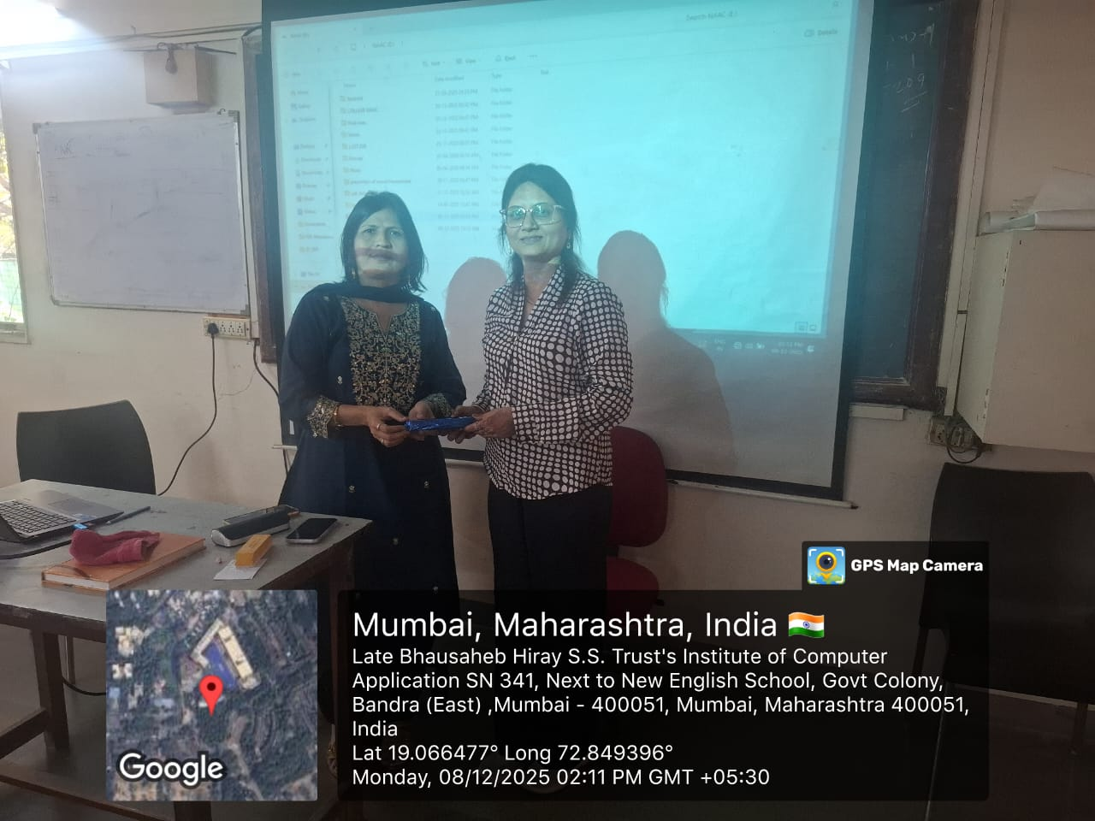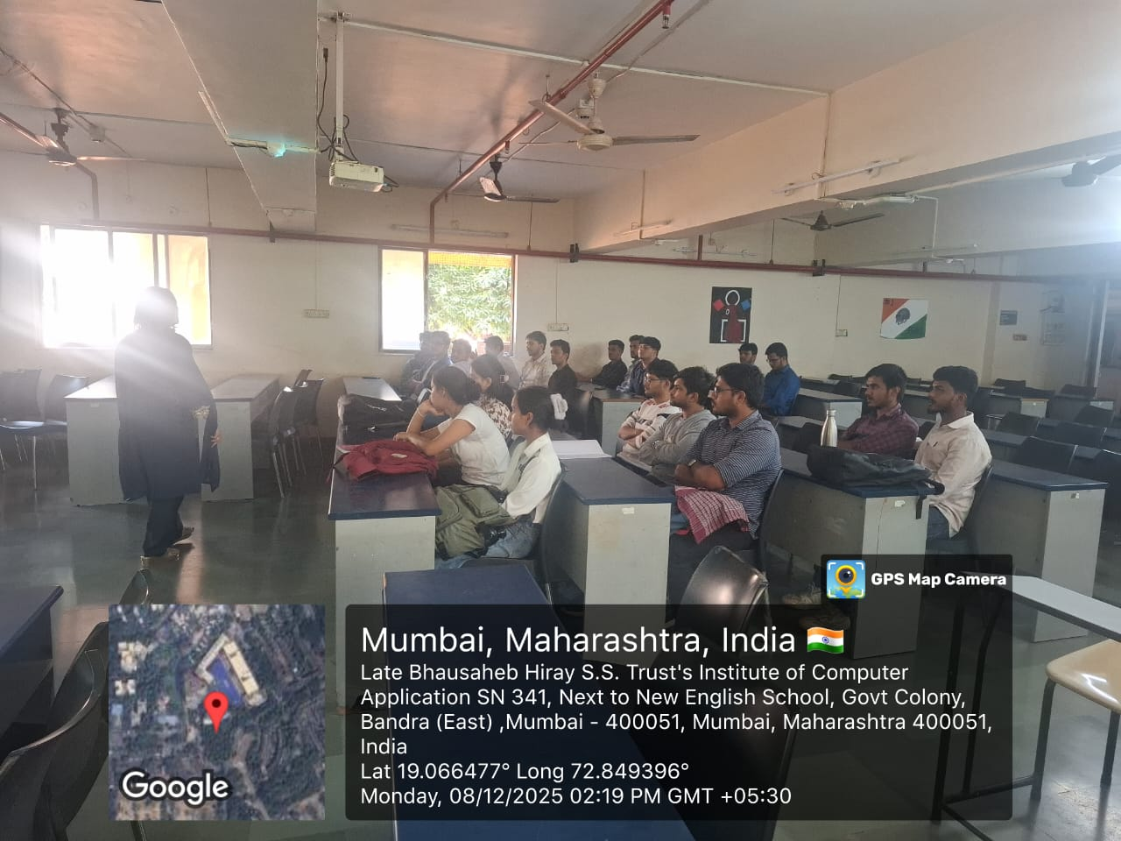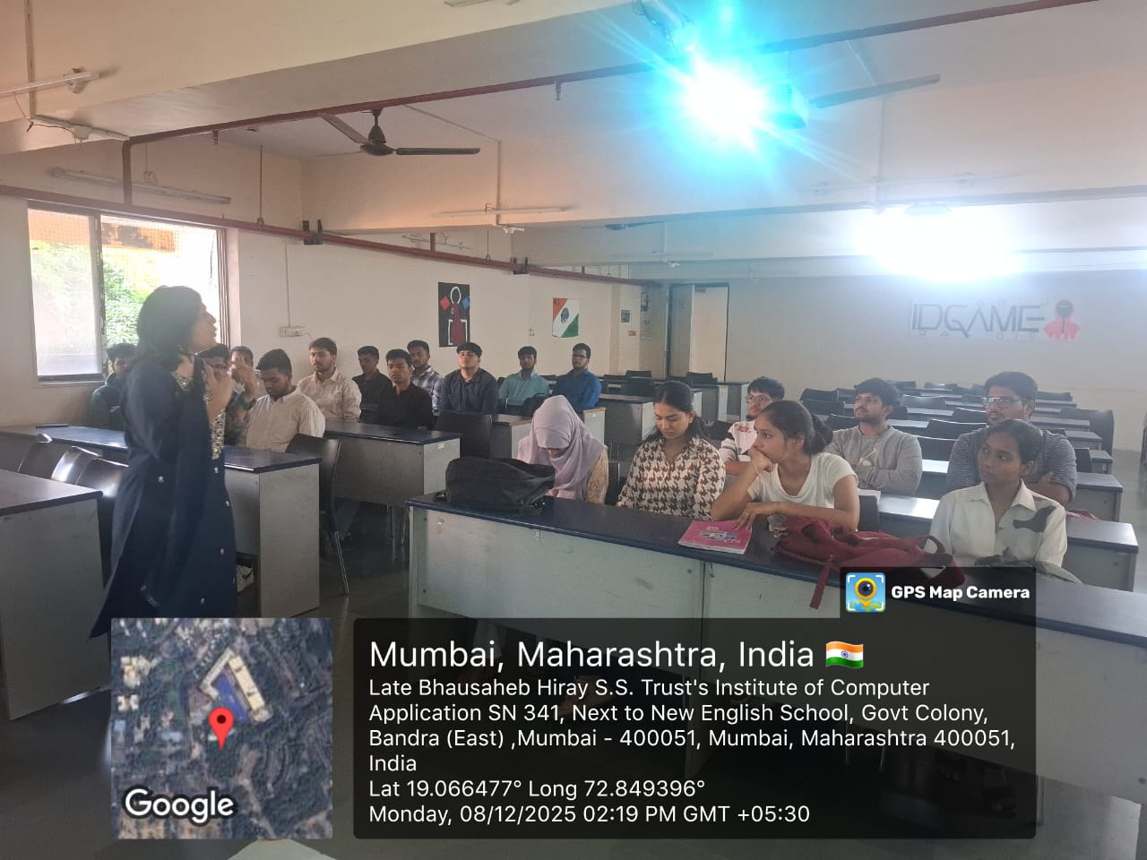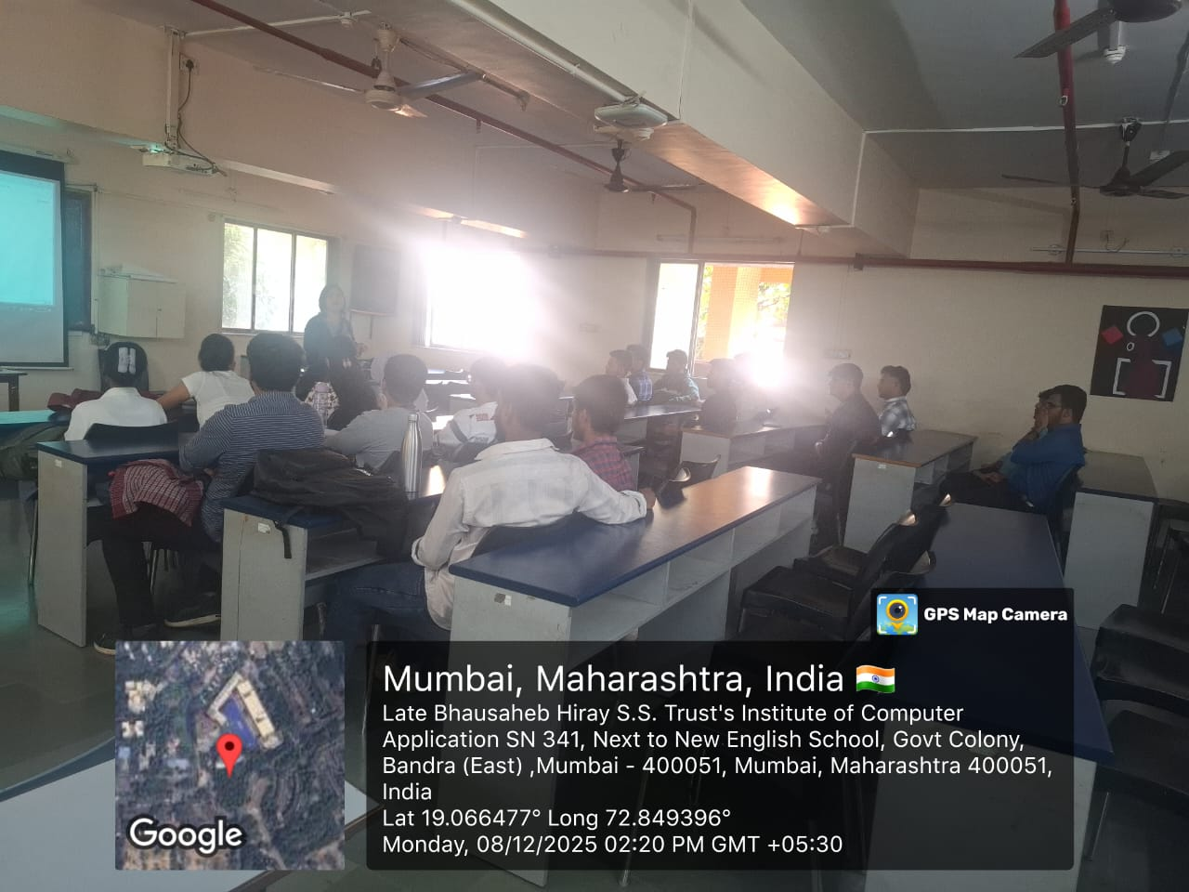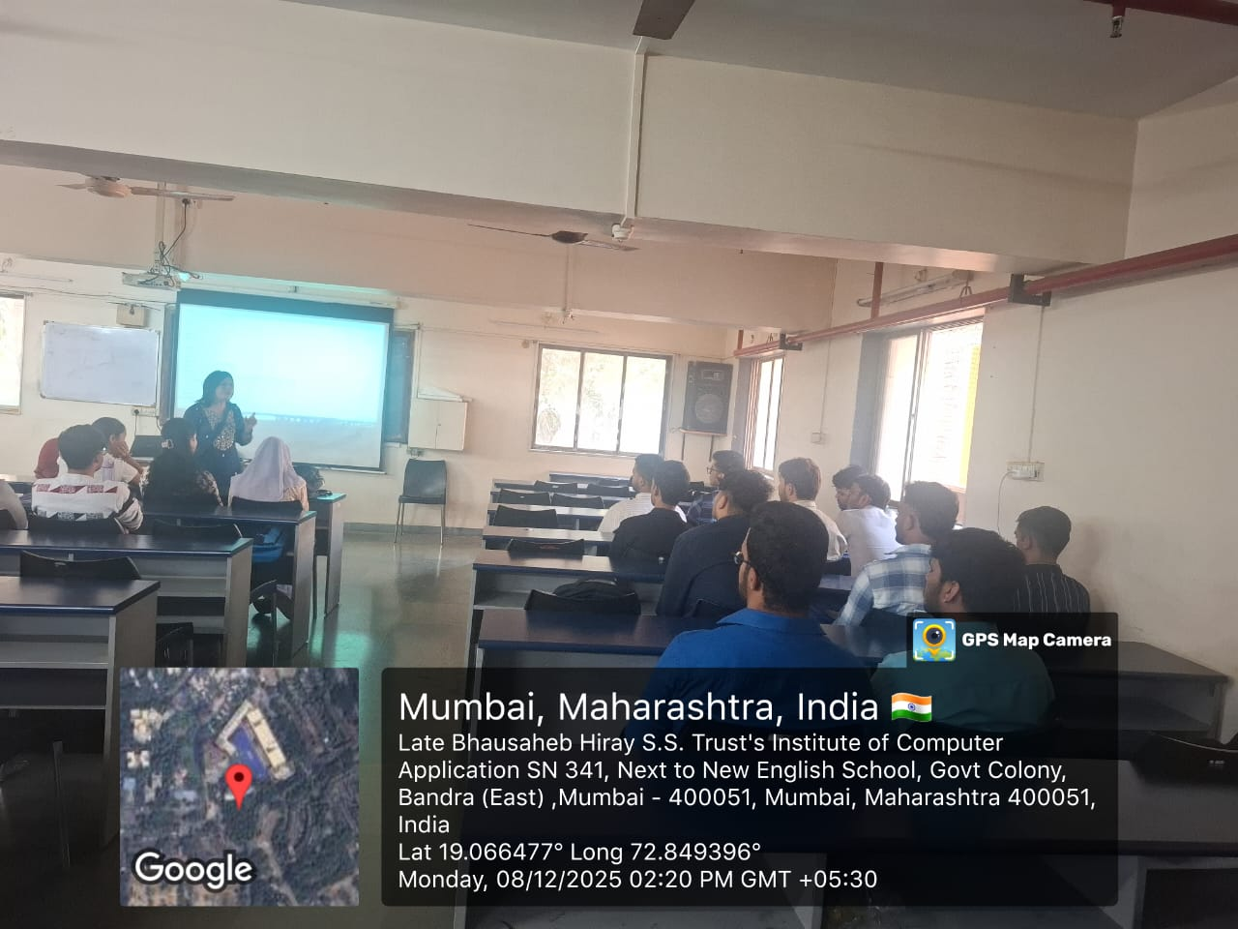
Feedback sample | Attached
Registration/ Attendance | Attached
Resource person profile information | Dr. Chaya Shah  College Name: Jitendra Chauhan College of Law  Phone Number: 9920365779

Event Coordinator Director

