Activity Report
Date: 23-09-2024
Topic: Yoga Session
Time – 10.00 am onwards
Resource person: Ms.Trupti Naik, Yoga Expert
An Induction Programme was conducted by the MCA Department from 18/09/2024 to 23/09/2024 with the intention of introducing first year students to the curriculum of MCA education.
Induction Training Programme on Yoga was organized by the MCA Department for the First year students on 23^{.rd} September 2024 with an objective to connect the mind, breath and body to improve overall health. Yoga can improve strength, balance, and flexibility. It can also help release tension in joints and organs, which can lead to increased well-being and strength.
The yoga expert introduced the students and the faculties with various types of yoga postures and breathing exercises with their benefits. The students enjoyed the physical and mental freshness during the entire session.

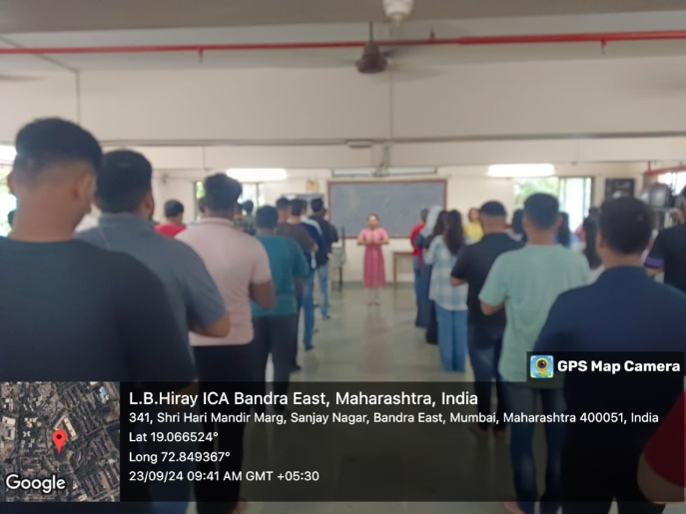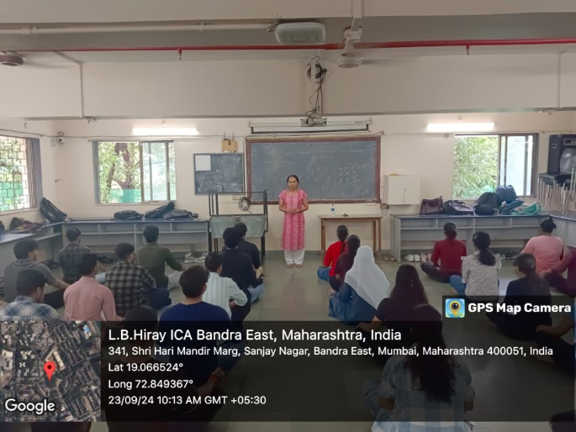
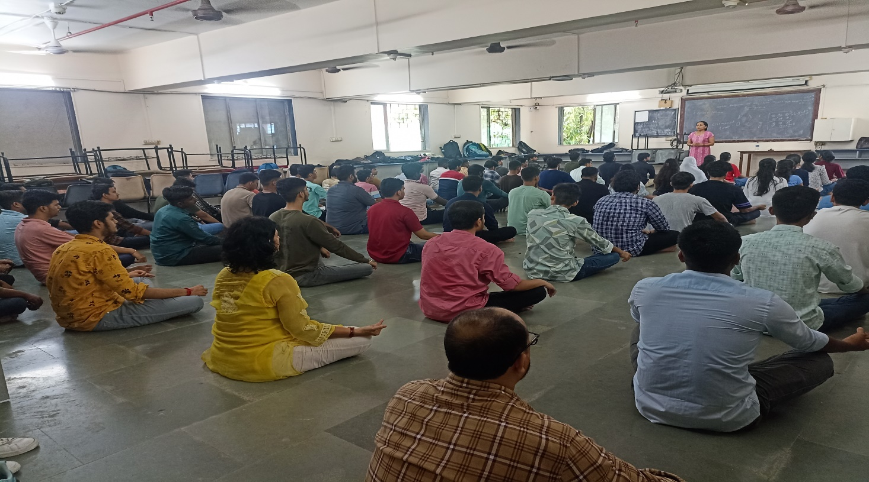

Outcome
The session turned to be effectual and the students were to a greater extent inspired by it. This practice served the purpose of soothing tension and anxiety in the mind and body. It tried to achieve one of the main goals of yoga to achieve tranquility of the mind and create a sense of well-being, feelings of relaxation, improved self-confidence, improved efficiency, increased attentiveness, lowered irritability, and an optimistic outlook on life.

Dr. Avantika Mahadik Prof. Tanuja Mahajan
Event Co-ordinator Director

