Activity Report
Date: 09-09-2025

Topic: Universal Human values
Time – 12pm
Resource person: Ms.Rutuja Chavan, Assistant Professor, MCA Department
An Induction Programme was conducted by the MCA Department from 08/09/2025 to 09/09/2025 with the intention of introducing first year students to the curriculum of MCA education.
Induction Training Programme on Human Values was organized by the MCA Department for the First year students on 9th September 2025 with an objective to orient, motivate and instill human values in the fresh minds, they must need to know what their own set of human values is because these provide guidelines on how they should behave with other people, at home and at colleges and at work.
The devastating gun culture and terrorists acts of the 21st century have given a clarion call to urge forward the human values and ethics in the younger generation, the hope of the nation.
Four different modules were discussed with considering the most vital aspects to be learnt. It was executed in an impactful and lively manner so as to reap essential harvest.

Module 1: Importance of UHV
Module 2: Types of UHV
Module 3: Harmony in self, family, society and nature
Module 4: Conclusion

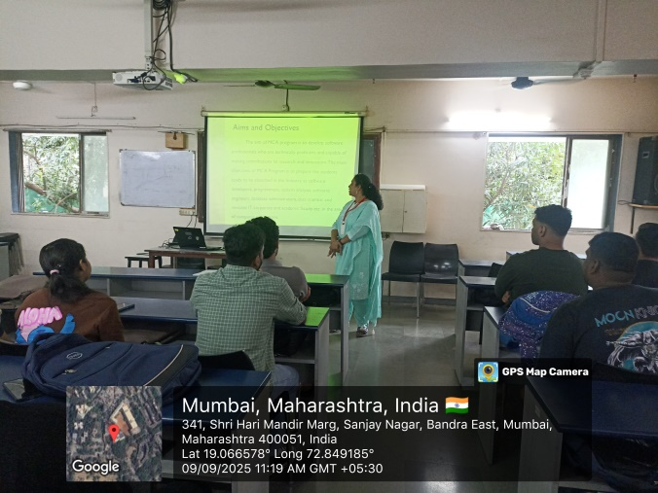 | 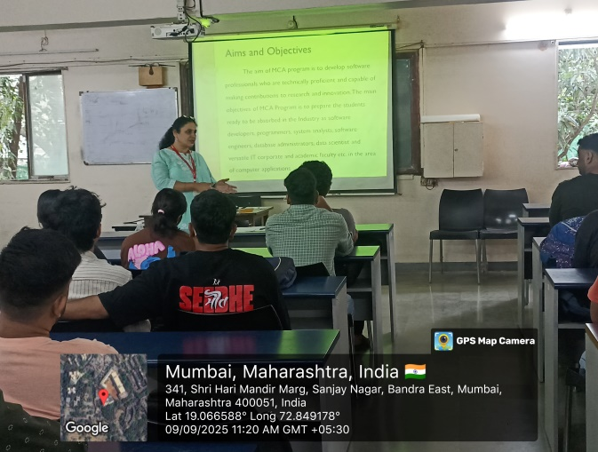

Outcome
The lecture turned to be effectual and the students were to a greater extent inspired by it. This lecture served the purpose of bridging the gap between a professional and a kind human being. It also paved way for the students to adapt contentedly to the environment and the system of education, our surrounding, our family and ourselves.

Mrs.Rutuja Chavan Prof. Tanuja Mahajan
Event Co-ordinator Director

