Activity Report
Date: 08-09-2025

Topic: Diagnostic Tests & Proficiency Modules short Courses
Time – 9.00 am onwards
Resource persons:
1) Ms.Khyati Manvar –English
2) Mr.Divakar Jha & Mr.Prakash Sakharkar – Mathematics
3) Ms.Sheetal Waghmare & Ms.Rutuja Chavan – Computer Operations

An Induction Programme was conducted by the MCA Department from 08/09/2025 to 09/09/2025 with the intention of introducing first year students to the curriculum of MCA education.
Induction Training Programme on Diagnostics Test was organized by the MCA Department for the First year students on 8th September 2025 with an objective to test and evaluate the basic knowledge of the core subjects , they are going to learn during the academic, they must need to know how much basic knowledge of the various subjects is needed to understand and complete the MCA curriculum.
Three different test modules were taken in the form of MCQs .Google form link for each subject was shared to the student in computer lab. The test was conducted for three hours( 1 hr for each subject) for which the result were declared to students on the same day.
The slow learner criteria was decided on the basis of below 80% result for which proficiency modules were performed to clear fundamentals of the above subjects in which some study materials, informative links were shared with students. Toppers from the tests were felicitated with claps and other students were motivated. PPTs for the prerequisite were presented for the computer subjects and students were asked to make their basic programming and essential technical knowledge more stronger.

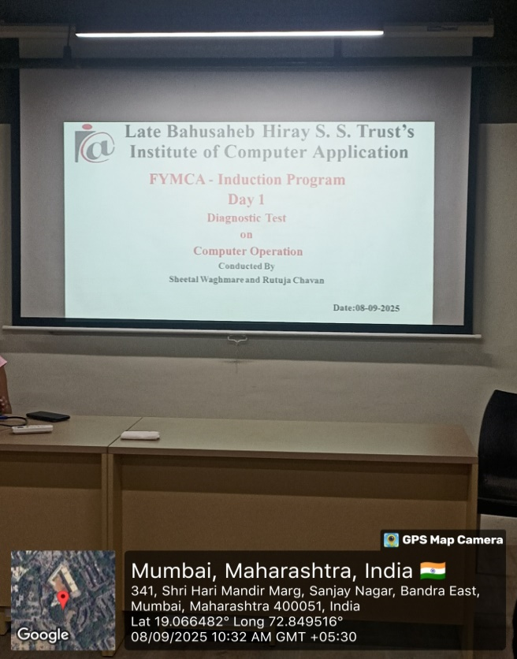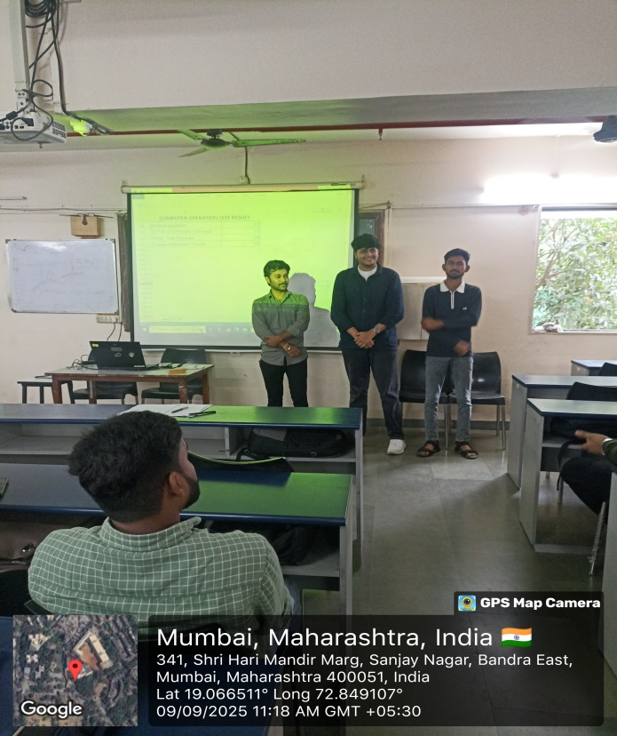
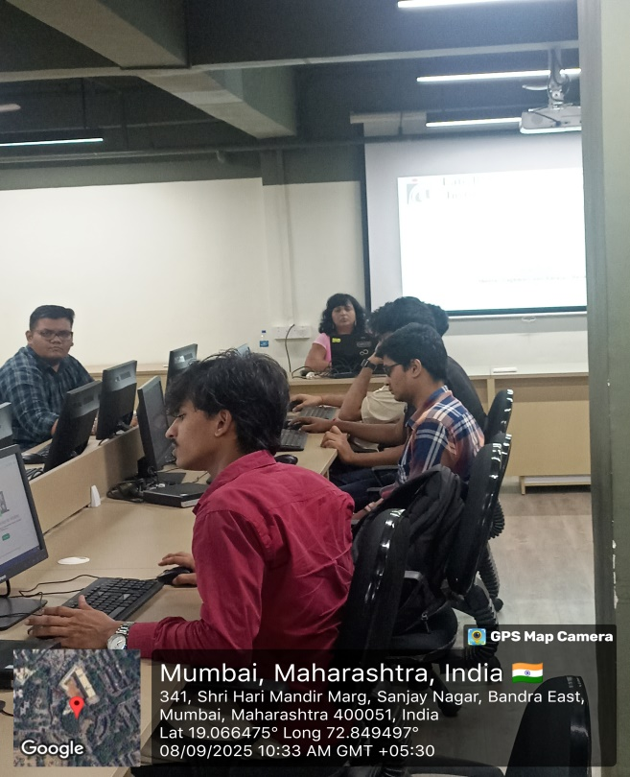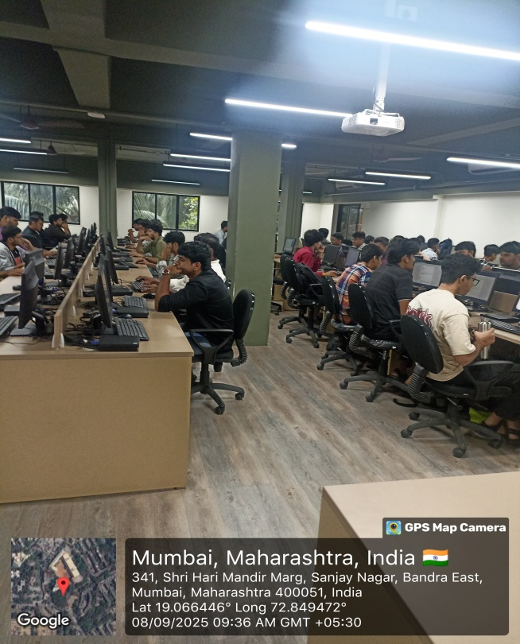

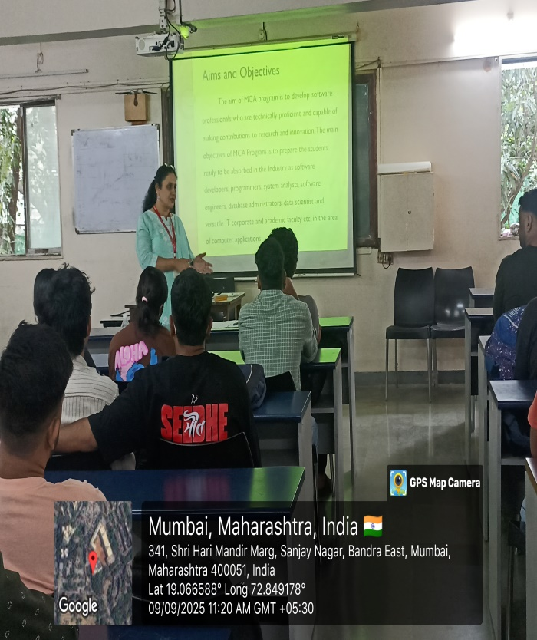 | 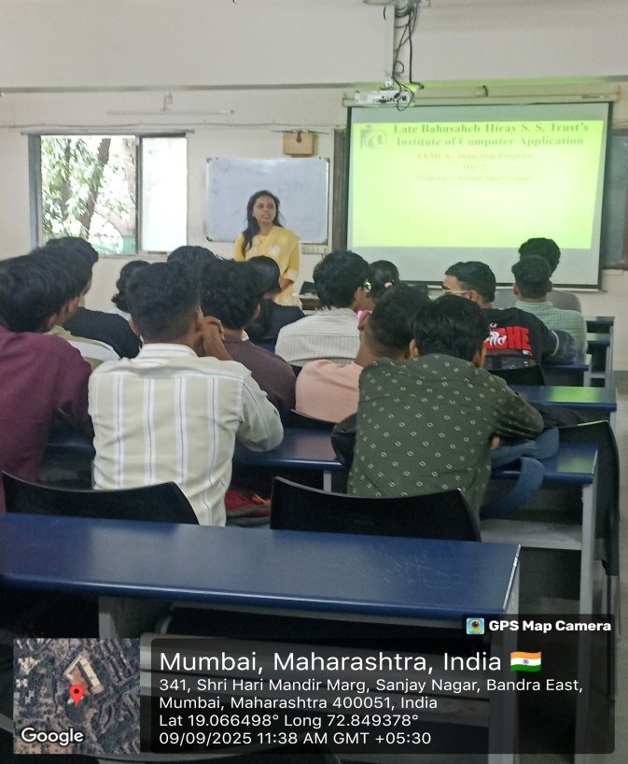
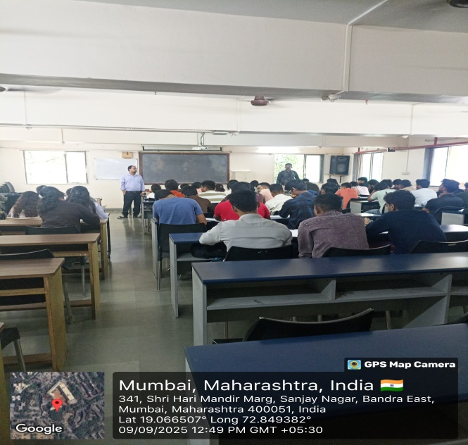 | 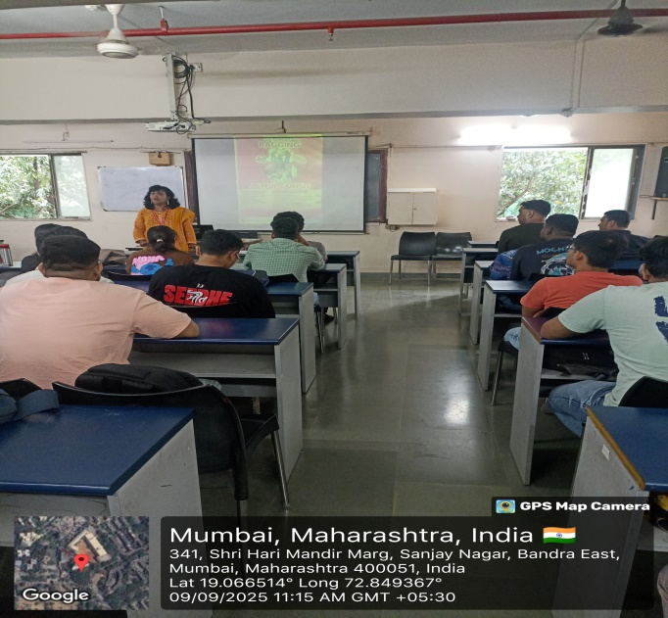

Outcome
The Diagnostic test and Proficiency modules turned to be effectual and the students were to a greater extent inspired by it. These programs served the purpose of clearing basic fundamentals of core subjects, they must needed in MCA Curriculum.

Ms.Rutuja Chavan Prof. Tanuja Mahajan
Event Co-ordinator Director

