Activity Report
Date: 08-09-2025

Topic : interpersonal communication
Time: 1Pm to 2 Pm
Resource Person: Gouri Johann (clinical psychologist and Psychotherapist)
An introductory programme was conducted by MCA department
Training programme on interpersonal communication was organized by MCA department for first year students on 8th September 2025 with an objective to enhance the positive self-concept, and effective interactive skills. Interpersonal communication is vital for students as it foster better relationship with peers and teachers. It helps to build leadership and teamwork skills, and teaches to resolve conflicts constructively.
The inhouse Psychologist gave her introduction to the student’s and inform about her availability in the campus for student’s mental health. The workshop was full of activities and students participated enthusiastically.

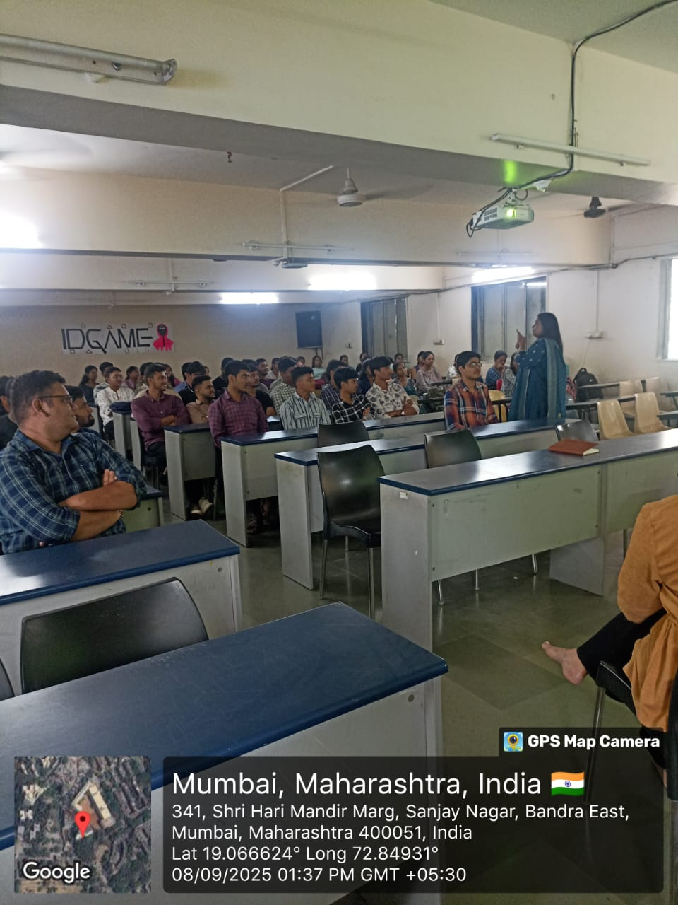 | 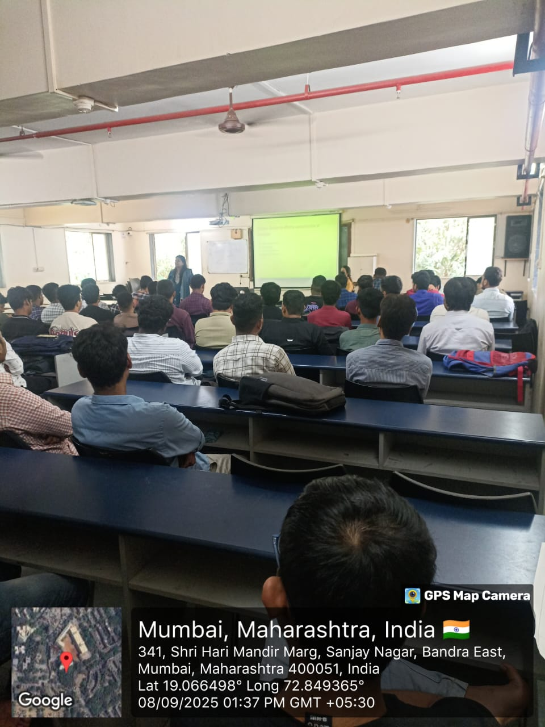

Outcome:
The session was effective as each participant come to know about each other throw interactive games. It helped them to understand the self-concept, importance of giving feedback and taking it effectively. They learn essential skills for interpersonal communication like active listening, tone and body language while talking, nonverbal communication, showing empathy and respect while interacting. Indeed it will impact on their academic performance, social relationships, and emotional wellbeing.

Mrs.Rutuja Chavan Prof. Tanuja Mahajan
Event Co-ordinator Director

